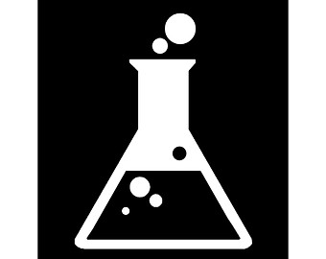 **ROSSMOYNE SENIOR HIGH SCHOOL**

**SEMESTER 1 EXAM 2017**

Multiple-choice Answer Sheet

|  |
| --- |
| Name: **MARKING KEY** |

**INSTRUCTIONS**

|  |
| --- |
| For each question shade the box to indicate your answer.  Use **only** a blue or black **pen** to shade the boxes.  For example, if b is your answer: a □ b ■ c □ d □  If you make a mistake, place a cross through that square and shade your new answer. **Do not** erase or use correction fluid/tape.  For example, if b is a mistake and d is your answer: a □ b ■ c □ d ■  If you then want to use your first answer b, cross out d and then circle b.  a □ b ■ c □ d ■  Marks will **not** be deducted for incorrect answers.  **No marks** will be given if more than one answer is completed for any question. |

|  |  |  |  |  |  |  |  |
| --- | --- | --- | --- | --- | --- | --- | --- |
| 1 | a □ b □ c ■ d □ |  | 6 | a □ b □ c ■ d □ |  | 11 | a □ b □ c □ d ■ |
| 2 | a ■ b □ c □ d □ |  | 7 | a ■ b □ c □ d □ |  | 12 | a □ b ■ c □ d □ |
| 3 | a ■ b □ c □ d □ |  | 8 | a □ b □ c ■ d □ |  | 13 | a □ b □ c ■ d □ |
| 4 | a □ b ■ c □ d □ |  | 9 | a □ b ■ c □ d □ |  | 14 | a □ b □ c ■ d □ |
| 5 | a □ b □ c ■ d □ |  | 10 | a □ b □ c □ d ■ |  | 15 | a □ b □ c ■ d □ |

|  |  |  |
| --- | --- | --- |
| 16 | a □ b □ c □ d ■ |  |
| 17 | a □ b □ c □ d ■ |  |
| 18 | a □ b ■ c □ d □ |  |
| 19 | a □ b ■ c □ d □ |  |
| 20 | a □ b □ c □ d ■ |  |

**Section Two: Short answer 33% (50 marks)**

This section has **eight (8)** questions. Answer **all** questions. Write your answers in the spaces provided.

When calculating numerical answers, show your working or reasoning clearly. Express numerical answers to the appropriate number of significant figures and include appropriate units where applicable.

Spare pages are included at the end of this booklet. They can be used for planning your responses and/or as additional space if required to continue an answer.

* Planning: If you use the spare pages for planning, indicate this clearly at the top of the page.
* Continuing an answer: If you need to use the space to continue an answer, indicate in the original answer space where the answer is continued, i.e. give the page number. Fill in the number of the question(s) that you are continuing to answer at the top of the page.

Suggested working time: 60 minutes.

**Question 21 (6 marks)**

Draw dot diagrams (Lewis structures) for the following. Show all valence shell electron pairs as either : or —

|  |  |  |  |  |  |
| --- | --- | --- | --- | --- | --- |
| For example, water |  | or |  | or |  |

|  |  |
| --- | --- |
| K+ | [ K ]+  **No electrons and square bracket (1)**  (1 marks) |
| NCℓ3 | Cℓ N Cℓ  Cℓ  **Correct Structure (1)**  **All valence e- (1)** (2 marks) |
| CuCO3 | [ Cu ]2+ [ O C O ]2-  **All valence e-**  **(1)** O  **CO32- (1) [ ] and charge (1)** (3 marks) |

**Question 22 (8 marks)**

Complete the following by giving the name or formula for the following:



|  |  |
| --- | --- |
| **Formula** | **Name** |
| Cu2O | ***Copper (I) oxide*** |
| CCℓ4 | ***Carbon tetrachloride or tetrachloromethane*** |
| Mg3(PO4)2 | ***Magnesium phosphate*** |
| ***Aℓ2(CO3)3*** | Aluminium carbonate |
| ***N2O3*** | Dinitrogen trioxide |
| ***CaSO3*** | Calcium Sulfite |
| ***Fe2(HPO4)3*** | Iron (III) hydrogenphosphate |
| ***NH4+*** | Ammonium ion |

**[1 mark each correct answer]**

**Question 23 (4 marks)**

Observe the table below:



|  |  |  |  |
| --- | --- | --- | --- |
| **Species** | **Protons** | **Neutrons** | **Electrons** |
| A | 6 | 6 | 6 |
| B | 6 | 8 | 6 |
| C | 6 | 7 | 10 |
| D | 11 | 12 | 10 |
| E | 12 | 12 | 10 |
| F | 8 | 8 | 10 |

Using the table above by writing correct letters into the appropriate boxes below.

|  |  |  |  |  |
| --- | --- | --- | --- | --- |
| **Isotopes** | ***A, B & C*** |  | **Neutral atoms** | ***A & B*** |
| **Anions** | ***C & F*** |  | **Cations** | ***D & E*** |

**[1 mark for correct for ALL correct letters in a box]**

**Question 24 (6 marks)**

Complete the table by drawing or naming the following hydrocarbons using IUPAC nomenclature.



|  |  |
| --- | --- |
| **Structure** | **IUPAC Name** |
| Cℓ H Cℓ  | | |  H – C – C – C – H  | | |  H H H | ***1,3 – dichloropropane***  **Correct Name (1)** |
|  | 1-bromo-2-methylbenzene  **Benzene ring (1)**  **Correct substituents (1)** |
| **Structure (1)**  **Trans (1)** | Trans- pent-2-ene |
| Br                    |             CH = C – CH2   |               |        Br             CH3 | ***Trans-1-2-dibromo-but-1-ene***  **Correct name (1)**  **Needs the *“trans”*** |

**Question 25 (8 marks)**

Consider the following reactions and complete the tables that follow.

* 1. Excess bromine water reacts with ethene gas in the dark. (4 marks)

|  |  |
| --- | --- |
| **Observation** | ***orange colour fades (is decolourised)* (1)** |
| **Balanced chemical equation with structural formula**  **(show all atoms)** | **H H Br Br**  **| | | |**  **H - C = C - H + Br2 🡪 H - C – C – H**  **| |**  **H H**  **Structural formula (1)**  **Correct balanced equation (1)**  **No further substitution** |
| **Name of organic product** | ***1,2 – dibromoethane* (1)** |

* 1. Propane is mixed with excess oxygen gas and ignited. (4 marks)

|  |  |
| --- | --- |
| **Observation** | ***Two colourless gases are mixed or***  ***Explosion occurs (heat and light energy released)* (1)** |
| **Balanced chemical equation with structural formula**  **(show all atoms)** | **H H H**  **| | |**  **H – C – C – C – H + 5 O2 🡪 4 H2O + 3 CO2**  **| | |**  **H H H**    **Structural formula (1)**  **Correct balanced equation (1)** |
| **Name of the products** | ***Carbon dioxide and water.* (1)** |

**Question 26 (7 marks)**

Write balanced **FULL** equations for the following reactions described below. Include the states of matter for all the species. For example, solid copper (II) sulfate as CuSO4 (s).

* 1. Carbon dioxide gas is bubbled into limewater (Ca(OH)2) to produce calcium carbonate precipitate.

(2 marks)

***CO2 (g) + Ca(OH)2 (aq) 🡪 CaCO3 (s) + H2O (ℓ)***

* 1. Silver nitrate solution is mixed with iron (II) chloride solution to produce solid silver chloride and iron (II) nitrate solution. (2 marks)

***2AgNO3 (aq) + FeCℓ2 (aq) 🡪 2AgCℓ (s) + Fe(NO3)2 (aq)***

* 1. Direct heating of solid bicarbonate of soda (sodium hydrogencarbonate). (2 marks)

***2NaHCO3 (s)  Na2CO3 (s) + H2O (ℓ) + CO2 (g)***

States of matter for of all species (1 mark)

**Correct equation (1) Each question**

**Balanced correctly (1) Each question**

**States of matter for entire question (1) only**

1. **(4 marks)**

Carbon dioxide is a colourless gas which occupies 0.04% of our atmosphere. The melting point and the boiling point of carbon dioxide are – 56.6 oC and – 78.5 oC respectively.

Explain why carbon dioxide has a very low melting and boiling point.

* ***Carbon dioxide is a covalent molecule.*  (1)**
* ***Force between CO2 is a weak intermolecular force (dispersion force)* (1)**
* ***Less heat energy to overcome this force.*  (1)**
* ***Therefore, the MP/BP are low.* (1)**

1. **(7 marks)**

The average human requires 120 grams of glucose (C6H12O6) per day.

* 1. Calculate the percentage by mass of carbon in each glucose molecule. (3 marks)

**(1)**

**(1)**

**(1)**

* 1. How many grams of CO2 (in the photosynthesis reaction) are required for this amount of glucose? The photosynthetic reaction is:

6CO2 + 6H2O 🡪 C6H12O6 + 6O2

(4 marks)

$n\left(C_{6}H_{12}O_{6}\right)=\frac{n}{M}=\frac{120}{180.156}=0.66609 mol$**(1)**

$n\left(CO_{2}\right)=\frac{6}{1}×n\left(C_{6}H_{12}O_{6}\right)=\frac{6}{1}×0.66609= 3.9965 mol$**(1)**

$m\left(CO_{2}\right)=n×M\left(CO_{2}\right)=3.9965×44.01$**(1)**

$=176 g (175.89g)$**(1)**

**End of Section Two**

**Section Three: Extended answer 40% (60 marks)**

This section contains **five (5)** questions. You must answer **all** questions. Write your answers in the spaces provided below.

Where questions require an explanation and/or description, marks are awarded for the relevant chemical content and also for coherence and clarity of expression. Lists or dot points are unlikely to gain full marks.

Final answers to calculations should be expressed to the appropriate number of significant figures.

Spare pages are included at the end of this booklet. They can be used for planning your responses and/or as additional space if required to continue an answer.

* Planning: If you use the spare pages for planning, indicate this clearly at the top of the page.
* Continuing an answer: If you need to use the space to continue an answer, indicate in the original answer space where the answer is continued, i.e. give the page number. Fill in the number of the question(s) that you are continuing to answer at the top of the page.

Suggested working time: 70 minutes.

1. **(13 marks)**

The following simplified diagram shows the path of a 20Ne+ ion through a mass spectrometer.

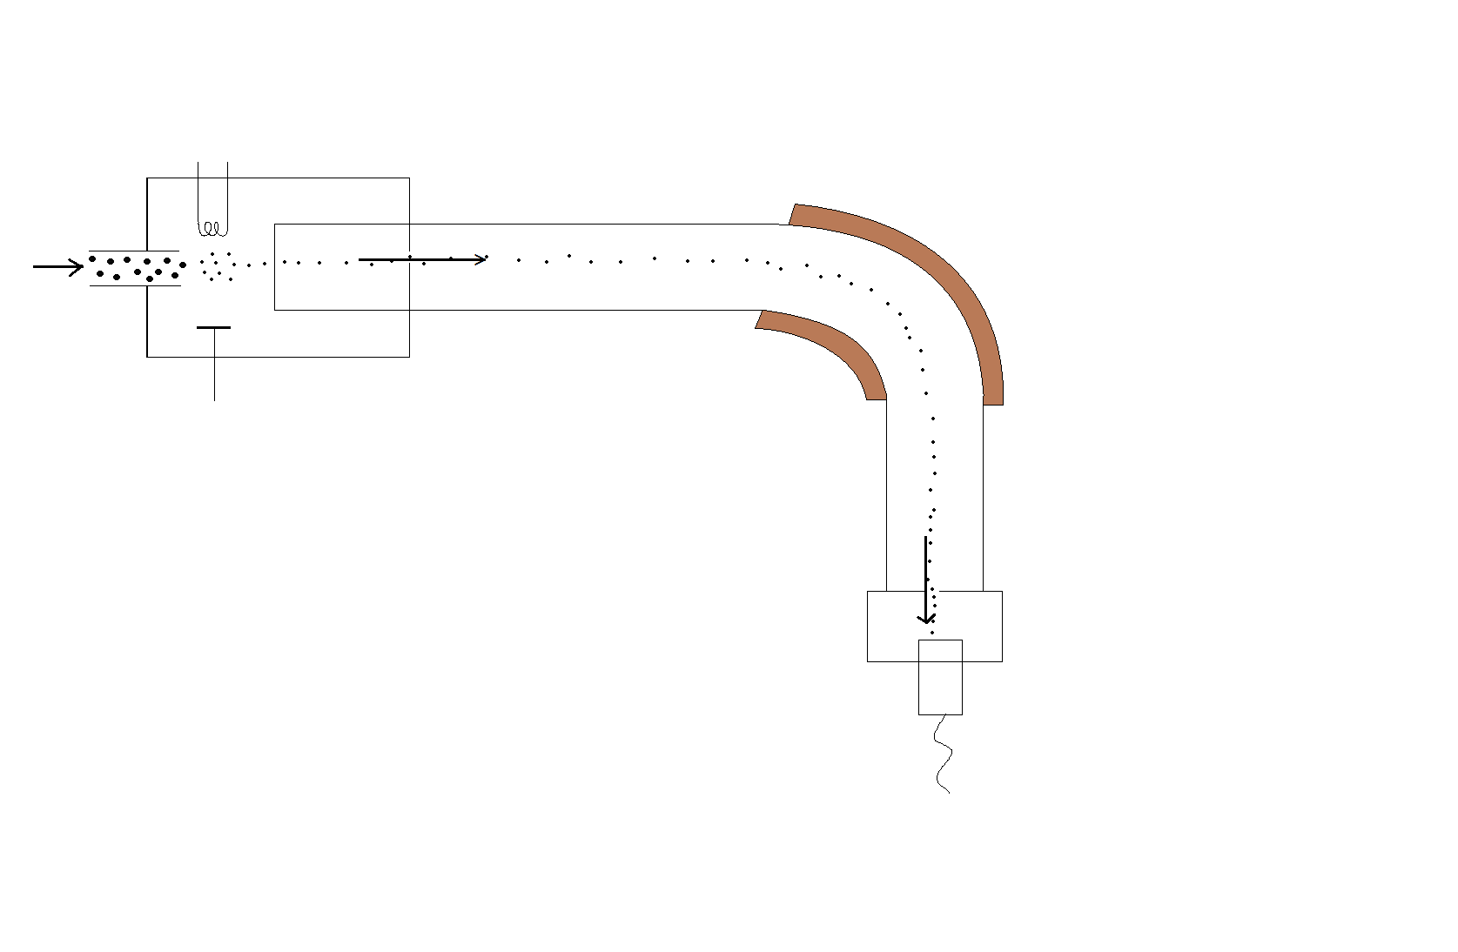

A



* + 1. What is the name of part A in this mass spectrometer? (1 mark)

***Magnet (or magnetic field)* (1)**

* + 1. Why is part A required in this mass spectrometer? (1 mark)

***When ions are passing the magnet or magnetic field, they change their direction/deflected.* (1)**

**Continue Question 29**

* + 1. On the diagram of the mass spectrometer, sketch the path that would be taken by a 21Ne+ ion introduced if it were into the spectrometer at the same time as the 20Ne+ ion shown. (1 mark)

**The curve should deviate less (i.e. greater curve around area A) (1)**

* + 1. Explain why the paths travelled by the two ions differ. (2 marks)
* ***Ne-21 ion has a larger mass than the Ne-20 ion, but both have same charge* (1)**
* ***As such it is bent (deflected) less than Ne-20 ion* (1)**

The relative abundances of all the neon isotopes in a sample is collected using the mass spectrometer. The result is shown below. Note that m/z value is equivalent to the mass number of a neon ion. (For example, m/z = 20 means 20Ne+ isotope.)

* 1. Use the above graph to calculate the relative atomic mass of neon. (2 marks)

$A_{r} \left(Ne\right) =$ $\frac{{[A}_{r }(Ne-20)×abundance]+ {[A}_{r }(Ne-21)×abundance]+ {[A}_{r }(Ne-22)×abundance]}{100}$

$=\frac{(20×90)+(21×1)+(22×9)}{100}$**(1)**

**= 20.19**

**= 20.2 (no units) (1)**



Atomic absorption spectroscopy (AAS) can be used to distinguish different elements such as neon and helium atoms. The diagram below shows the emission spectra of helium and neon.

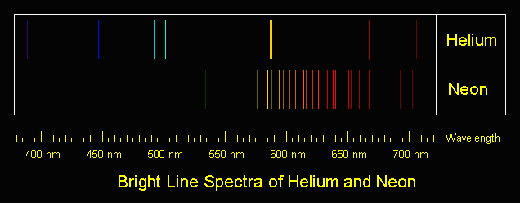

* 1. Explain how these spectra lines are produced. (3 marks)

* ***e- are excited and jump to higher energy levels using/by absorbing energy.* (1)**
* ***When e- are coming to lower energy levels, photons (light) is emitted.* (1)**
* ***Different jumps between energy levels will produce different colours.*  (1)**
  1. The spectra of helium and neon are different. Give an explanation for this.

(3 marks)

* ***Helium (2 e-) and neon (10 e-) have different numbers of e- and different numbers of energy levels (electron shells).* (1)**
* **The photon emitted has energy equal to the difference in energy between the levels. (1)**
* **The photons emitted would be unique to each element (characteristic) (1)**

1. **(17 marks)**

Nanoparticles are particles between 1 and 100 nanometres in size. In nanotechnology, a particle is defined as a small object that behaves as a whole unit with respect to its transport and properties. Ultrafine particles are the same as nanoparticles and are between 1 and 100 nanometres in size, fine particles are sized between 100 and 2,500 nanometres, and coarse particles cover a range between 2,500 and 10,000 nanometres. Scientific research on nanoparticles is intense as they have many potential applications in medicine, optics, and electronics.

* 1. How do bulk materials differ from nanoparticles mentioned above?

(2 marks)

* ***Bulk material should have constant physical properties regardless of its size.* (1)**
* ***Nano-scale size-dependent properties are often observed.*  (1)**
  1. Explain the advantages and concerns of the use of nanoparticles in some sunscreens.

(4 marks)

* ***Sunscreens interact with UV radiation using nanoparticles, such as titanium dioxide or zinc oxide, form a physical barrier, reflecting or scattering UV waves.* (1)**
* ***The particles are so small that they are invisible. Nanotechnology has made it possible to produce completely clear sunscreens which still reflect/scatter UV rays just as effectively.*  (1)**
* ***The small particles may enter body and cause harm.*  (1)**
* ***Some unknown effects such as causing cancers.*  (1)**

Carbon nanotubes (CNT’s) are allotropes of carbon with a cylindrical nanostructure. An example of a CNT is shown on the right.

* 1. List TWO benefits of CNT’s.

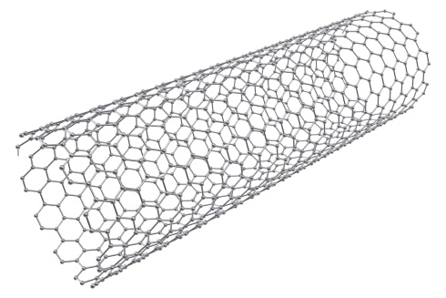(2 marks)

* ***Light weight.***
* ***High thermal and electrical conductivity.***
* ***Very strong.***

**Any two (2)**

* 1. Diamond and graphite are also allotropes of carbon. What does it mean by allotropes?

(2 marks)

* ***Allotropes are different forms of the same element which exhibit different physical properties.***

**(2)**

* 1. With the use of a labelled diagram, describe the chemical bonding and structure of graphite. (7 marks)
* ***Each carbon atom is covalently bonded to three other carbon atoms.* (2)**
* ***Form a 2D sheet with hexagonal structure.*  (1)**
* ***One delocalised e- from each carbon between layers.* (1)**
* ***The covalent bonds between carbon is so strong that the MP/BP are very high.* (1)**

|  |
| --- |
| **Diagram**    **Diagram (1)**  **Label (1)** |

1. **(16 marks)**

When magnesium metal reacts with oxygen from the air, a grey-white solid is formed. This chemical reaction can be performed in a crucible in the science lab.

* 1. Write a balanced chemical equation for this reaction. (2 marks)

***2 Mg (s) + O2 (g)🡪 2 MgO (s)* Correct reactants/products (1) correct coefficients (1)**

The setup of the combustion reaction is shown below:

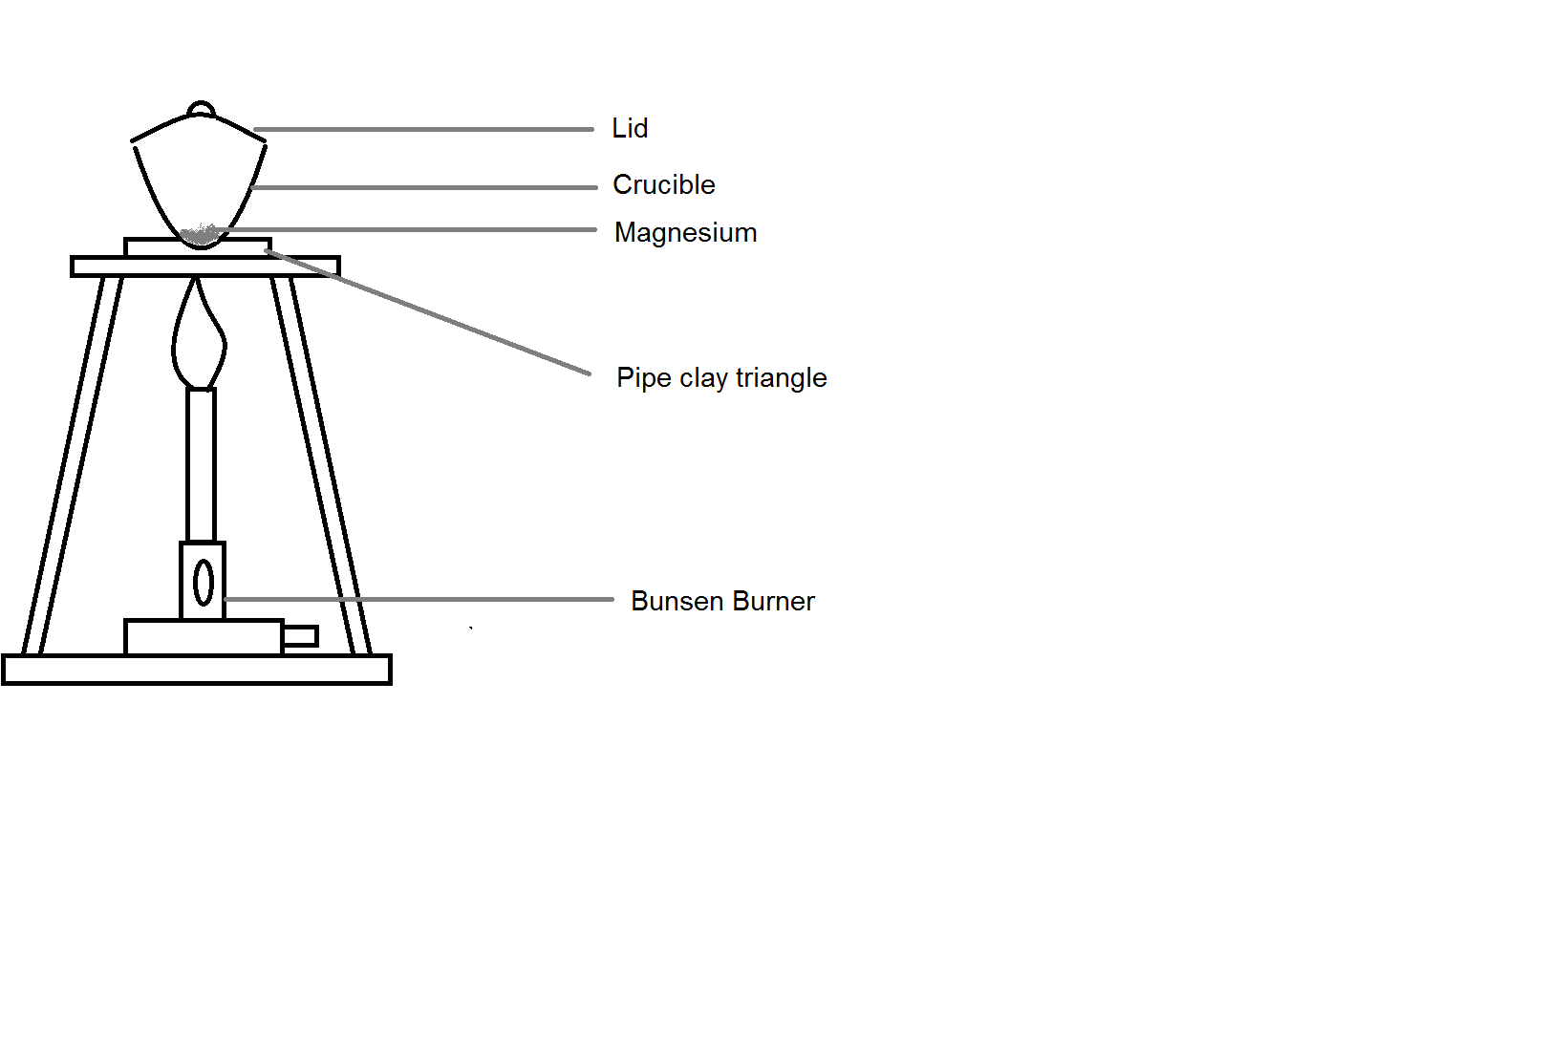

A student, Paul, wants to use this experiment to find the mass of oxygen reacting with the magnesium.

* 1. The teacher of the student, Mrs Philips, suggests that the lid of the crucible need to be open slightly during the combustion. Explain the reason for this. (1 mark)
* ***To allow more O2 into the crucible to undergo combustion*  (1)**

**(or equivalent)**

After the experiment, Paul summarises his result as follows:

Mass of crucible and lid (g) 38.5980 g

Mass of crucible, lid and magnesium (g) 38.7860 g

Mass of crucible, lid and magnesium oxide (g) 38.8873 g

* 1. Use Paul’s results to calculate:

(2 marks)

|  |  |
| --- | --- |
| **Mass of Magnesium (g)** | **0.1880 g** |
| **Mass of Magnesium oxide (g)** | **0.2893 g** |

* 1. Calculate the number of moles of magnesium at the beginning of the experiment. (2 marks)

**(1) (1)**

* 1. Calculate the number of moles of magnesium oxide produced at the conclusion of the experiment. (2 marks)

**(1) (1)**



* 1. Using your equation and answer from part (d), calculate the number of moles of magnesium oxide Paul is **expected** to produce in this experiment. Explain why the expected value is different to part (e). (3 marks)
* ***Expected: 7.733x10-3 mol of MgO*  (1)**
* ***Molar ratio of Mg : MgO is 1:1*  (1)**
* ***Not all Mg may undergo chemical reaction (or equivalent)*  (1)**
  1. Use the answer from part (d), calculate the theoretical mass of the oxygen gas reacted in this combustion. How does this value compare to the amount which actually reacted? (4 marks)

$n\left(MgO\right)theoretical=7.733×{10}^{-3}mol$

$∴n\left(O_{2}\right)theoretical=\frac{1}{2}×n\left(MgO\right)= \frac{1}{2}×7.733×{10}^{-3}$**(1) $=3.867×{10}^{-3} mol$**  **(1)**

$∴m\left(O_{2}\right)theoretical=n × M= 3.867×{10}^{-3}×32.00$ $=0.1237 g$**(1)**

**The theoretical mass of oxygen gas would be more than the actual mass of oxygen gas that reacted. (1)**

**Deduct 1 mark max for innapropriate use of sig figs in this question (Rounding down in the data table or writing down what their calculators say)**

1. **(9 marks)**

A fuel is any material that can be made to react with oxygen gas so that it releases energy as heat. Fossil fuels are fuels from natural processes such as anaerobic decomposition of buried dead organisms. One example of a fossil fuel is ethane.

The **unbalanced** chemical equation of the combustion of ethane is shown below:

***2*** C2H6 + ***7*** O2 🡪 ***4*** CO2 + ***6*** H2O

**(1)**

* 1. Balance the chemical equation above using whole numbers.

(1 mark)

* 1. Draw dot diagram (Lewis structures) for C2H6. Show all valence shell electron pairs as either : or — (2 marks)

|  |  |  |  |  |  |
| --- | --- | --- | --- | --- | --- |
| For example, water |  | or |  | or |  |

|  |  |
| --- | --- |
| C2H6 | **H H**  **| |**  **H – C – C – H**  **| |**  **H H**  **(2)** |

1.00 tonne of ethane is pumped into a combustion chamber to undergo this combustion reaction. Assume that there is no loss of energy in the reaction.

* 1. Calculate the number of moles of ethane reacted. (2 marks)

$$n\left(C_{2}H_{6}\right)=\frac{m}{M}$$ $=\frac{1.00×{10}^{6}}{[\left(12.01×2\right)+\left(1.008×6\right)]}$**(1) $=3.33×{10}^{4} mol$**  **(1)**

**Continue Question 32**

* 1. Calculate the mass, in tonnes, of oxygen required in this reaction if the ethane is fully reacted. (4 marks)

$n\left(O_{2}\right)=\frac{7}{2}×n\left(C_{2}H_{6}\right)$**(1) $=\frac{7}{2}×3.33×{10}^{4}= 1.16×{10}^{5}mol$ (1)**

$m\left(O_{2}\right)=n×M=1.16×{10}^{5}×32.00$**(1) $=3.72 ×{10}^{6}grams$**

$=3.72 tonnes$**(1)**

**Question 33 (5 marks)**

The strength of a covalent bond can be measured by looking at the energy required to break a mole of bonds.

For diatomic molecules this is:

Energy + X2 (g) → X (g) + X (g)

A table below shows the bond enthalpies for the halogens

|  |  |
| --- | --- |
| Halogen | ΔH (kJmol-1) |
| Cl2 | 242 |
| Br2 | 193 |
| I2 | 151 |

1. What is a covalent bond? (2 marks)

**Sharing of electrons forming a molecule (1)**

**The nuclei of each atom is attracted to the shared electrons (1)**

1. Using your knowledge of periodic trends and bonding, explain the trend seen in the table above. (3 marks)

**Down the group atomic size increases (1)**

**Puts shared electrons further away from the nucleus (1)**

**Same effective nuclear charge for shared electrons, has less attractive forces making it easier to break the molecule into separate atoms (1)**

**End of examination.**

**Acknowledgements**

**Question 37** S., M., Goldwasser, Sam’s Laser FAQ [image]. Retrieved November 2016, from http://www.2lss.de/laserfilez/downloads/Misc/laserfaq/laserioi.htm.

**Question 38** The structure of the graphene tube nanotechnology - 3d illustration,iStock Photo [image]. Retrieve December 2016, http://www.istockphoto.com/au/photo/the-structure-of-the-graphene-tube-nanotechnology-3d-illustration-gm542811892-97256529.

WATP acknowledges the permission of School Curriculum and Assessment Authority in

providing instructions to students.

